ABDURRAHMAN QURESHI

210451

EXP19

**1)CODE:**

#include<iostream.h>

#include<stdio.h>

#include<conio.h>

#include<stdlib.h>

#include<fstream.h>

void main()

{

clrscr();

ifstream ifiles1,ifiles2;

ofstream ifilet;

char ch,fname1[20],fname2[20],fname3[30];

cout<<"\nEnter the fisrt file name:";

gets(fname1);

cout<<"Enter the second file name:";

gets(fname2);

cout<<"Enter the third file name:";

gets(fname3);

ifiles1.open(fname1);

ifiles2.open(fname2);

if(ifiles1==NULL||ifiles2==NULL)

{

perror("error msg");

cout<<"Press any key to exit\n";

getch();

exit(EXIT_FAILURE);

}

ifilet.open(fname3);

if(!ifilet)

{

perror("error msg");

cout<<"Press any key to exit\n";

getch();

exit(EXIT_FAILURE);

}

while(ifiles1.eof()==0)

{

ifiles1>>ch;

ifilet<<ch;

}

while(ifiles2.eof()==0)

{

ifiles2>>ch;

ifilet<<ch;

}

cout<<"\nTwo files were merged into "<<fname3<<" file successfully..!!";

ifiles1.close();

ifiles2.close();

ifilet.close();

getch();}

**Output :**



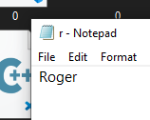

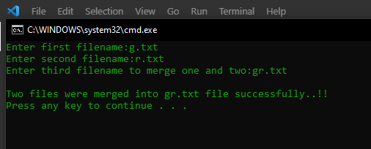

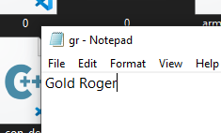

**2)Code:**

#include<stdio.h>

#include<conio.h>

#include<string.h>

#include<fstream.h>

#include<stdlib.h>

void main()

{

clrscr();

ifstream ifile;

char s[100],fname[20];

cout<<"\nEnter file name to read and display its content : ";

cin>>fname;

ifile.open(fname);

if(!ifile)

{

cout<<"\nError in opening file..!!";

getch();

exit(0);

}

while(ifile.eof()==0)

{

ifile>>s;

cout<<s<<" ";

}

cout<<"\n";

ifile.close();

getch();

}

Output :

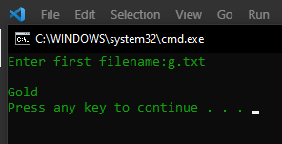

**3)Code:**

#include<iostream.h>

#include<conio.h>

#include<dirent.h>

void main()

{

clrscr();

DIR *dir;

dirent *pdir;

cout<<"\nFiles in the current directory:\n";

getch();

dir=opendir(".");

while(readdir(dir))

{

pdir=readdir(dir);

cout<<pdir->d_name<<"\t";

}

closedir(dir);

getch();

}

Output :

